Leamington & District Chess League, Minutes of 2009 Annual General Meeting, 12 May, 2009 at Kenilworth

Present (23): Steve Rumsby (Banbury), Gordon Mills (Chipping Campden), Alan Eley, Robert Stevens (Daventry), Mike Johnson, Dave Shurrock, Bernard Rogers, Phil Wood (Kenilworth), Steve Burnell, Guy Greenland, Jason Madden (Leamington), David Cheshire, Alan Lloyd, Robert Reynolds (Olton), Louis Rawson, Dave Thomas (Shirley & Lucas), Rob Anderton (Solihull), Jill Weaving (Solihull Checkmates), Dave Bowie, Karl Brough, Dino Darosa, Jonathan Rashleigh, Peter Stiff (Stratford).

Minutes of 2008 AGM: These were accepted as a true record and signed by the Chairman. ( This year, for the first time, the minutes had been available for all to see on the website.)

Matters arising: Nil.
Reports of League Officers

- Chairman – Bernard Rogers.
Thanks were given to Steve Rumsby who had done an enormous amount of work in the week by week collection of results and updating of the Website. He also thanked Richard and Rob Reynolds for again running the Lightning Tournament so smoothly.
This season had more close finishes than many years. Olton A ran away with Division 1, but in Division 4, four teams ended level on points, and Kenilworth D and Leamington D finished with exactly the same record ( of PWDL and +/-). Also, in Division 2, three teams had a chance of winning the division only a week before the end of the season.
- Secretary – Phil Wood.
There were no disputes this season which reached the committee, and everything ran reasonably smoothly. We had an application from South Birmingham C.C. to put a team into our league, and they were advised to send a representative to the AGM. (but no-one came).
- Treasurer – Guy Greenland.
Finances were reported as being in a healthy state, though we have no revenue at the moment from website advertising; however,the Tournament this year made a small surplus. We have enough in reserve to cover a slight increase in ECF Game Fee, so no increase in League Fees is needed.

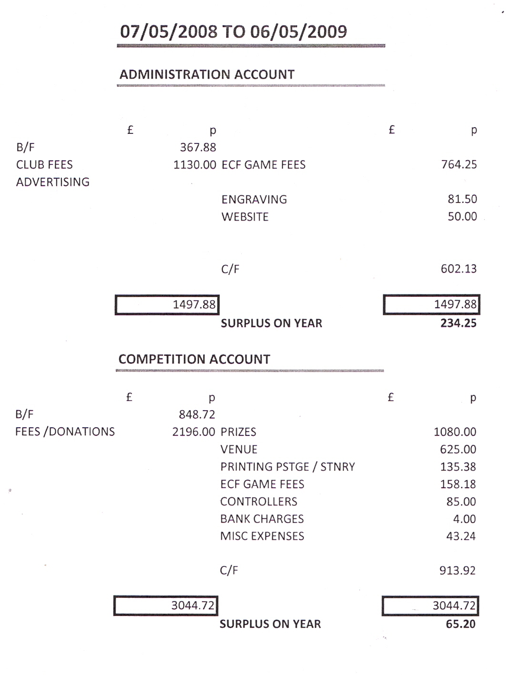

The Accounts for 2008 – 2009 as above were circulated and accepted by the meeting. As Director, Guy thanked the arbiters and others who helped to make the Tournament a success.

- Grading Officer – Dave Shurrock.
Rapidplay data were processed in time for the end of December deadline, and processing of League data is going well, and should be completed in time for the End May deadline.
Thanks were given to everyone who had sent details of new players in the League, and a reminder given to Clubs to send in details of their new players, especially junior players, along with their dates of birth.
Next season we shall be using the new grades and their respective calculation method.

- Competitions Secretary – Phil Wood
All three Competitions finished reasonably well on time, with no serious delays at any point, though a few people benefited from a gentle reminder. The committee will have to approve a better wording of the rules for the Competitions for next season.

- Fixtures Secretary, Web Master and Handbook Editor – Steve Rumsby
The Website appeared to have been used rather more this year. There were no particular problems except for some lost e-mails.
By the end of April, two fixtures had not been completed, and during the season six matches were defaulted. There were three minor incidents, one over time limits, another over wrong grading information.
Clubs were reminded that before the start of next season, they must submit details of their team Captains together with their phone numbers and e-mail addresses, and also any change of venue of their Club.
To help in making the fixture list for next season, Clubs are asked to give dates when any team is not available to play. Also, Steve needs to know if a Club does not want two of its teams to be scheduled together.

- ECF Representative
There was no report, in the absence of Gordon Christie.

Presentation of trophies by the Chairman

Team Competitions
League Division 1 Olton
Division 2 Solihull Checkmates
Division 3 Kenilworth C
Division 4 Kenilworth D and Leamington D
Knockout Cup – Open Olton
625 Shirley and Lucas
U100 Leamington 1

Individual Knockout Cup
Open Mark Page
U125 Mike Johnson
U100 Jason Madden

Other Tournaments
Lightning Philip Holt
Lightning U125 Iain Brodie
Stanley Gibbens Trophy
Best Game Prize

League Tables 2008/2009 Updated 03/05/09
Division 1
Team | Played | Won | Drawn | Lost | +/- | Points
Olton A | 14 | 12 | 1 | 1 | 23 | 25
Stratford A | 14 | 7 | 4 | 3 | 5 | 18
Leamington A | 14 | 7 | 3 | 4 | 8 | 17
Kenilworth A | 14 | 4 | 5 | 5 | -1 | 13
Solihull A | 14 | 3 | 7 | 4 | -8 | 13
Olton B | 14 | 4 | 3 | 7 | 3 | 11
Banbury A | 14 | 3 | 4 | 7 | -7 | 10
Shirley & Lucas A | 14 | 0 | 5 | 9 | -23 | 5

Division 2
Team | Played | Won | Drawn | Lost | +/- | Points
Solihull Checkmates | 16 | 10 | 2 | 4 | 17 | 22
Banbury B | 16 | 9 | 4 | 3 | 15 | 22
Kenilworth B | 16 | 7 | 6 | 3 | 10 | 20
Olton C | 16 | 7 | 4 | 5 | 2 | 18
Shirley & Lucas B | 16 | 7 | 3 | 6 | 2 | 17
Leamington B | 15 | 4 | 4 | 7 | -8 | 12
Stratford B | 16 | 4 | 2 | 10 | -14 | 10
Daventry A | 15 | 4 | 2 | 9 | -16 | 10
Chipping Campden A | 14 | 3 | 3 | 8 | -12 | 9

Division 3
Team | Played | Won | Drawn | Lost | +/- | Points
Kenilworth C | 14 | 11 | 2 | 1 | 20 | 24
Shirley & Lucas C | 14 | 8 | 2 | 4 | 10 | 18
Leamington C | 14 | 8 | 2 | 4 | 7 | 18
Solihull B | 14 | 7 | 3 | 4 | 9 | 15
Chipping Campden B | 14 | 6 | 3 | 5 | -1 | 15
Rugby | 14 | 5 | 1 | 8 | -10 | 11
Daventry B | 14 | 3 | 1 | 10 | -14 | 7
Stratford C | 14 | 1 | 0 | 13 | -21 | 2

Division 4
Team | Played | Won | Drawn | Lost | +/- | Points
Kenilworth D | 12 | 6 | 2 | 4 | 4 | 14
Leamington D | 12 | 6 | 2 | 4 | 4 | 14
Nuneaton | 12 | 6 | 2 | 4 | 2 | 14
Kenilworth E | 12 | 6 | 2 | 4 | 0 | 14
Stratford D | 12 | 4 | 2 | 6 | -3 | 10
Banbury D | 12 | 3 | 3 | 6 | -3 | 9
Solihull C | 12 | 4 | 1 | 7 | -4 | 9

Election of Officers

Post Elected Proposed Seconded
Chairman - - -
Secretary P.Wood R.Reynolds D.Shurrock
Treasurer G.Greenland J.Madden S.Rumsby
Grading D.Shurrock D.Thomas R.Stevens
ECF Representative The AGM agreed to try to re-engage Gordon Christie
Competitions Secretary P.Wood R.Stevens S.Rumsby
Fixtures Secretary, Webmaster Steve Rumsby R.Stevens L.Rawson
and ''Handbook'' Editor
Congress Director G.Greenland J.Madden D.Thomas
Trophies Officer B.Rogers
i/c Lightning Tournament Richard Reynolds Rob Reynolds D.Thomas

Any Other Business

- Subscriptions- will be £10 per player as before.
- A vote was taken on increasing board fee by £1 to pay for a printed handbook, with a large majority against.
- Dave Thomas explained at some length the effect of the revision of grades to be implemented by the ECF for next season, players on a grade of around 100 being expected to go up by about 20 points and a player now graded 150 going up by about 10 points. He proposed that the U100 Competitions should go up to U120, and that the U625 team Competition should go up to U700, with a maximum grade per player of 155. This was carried by a vote of 14 to 0. (This would make the U125 Individual into U140 on a pro rata basis.)
Louis Rawson suggested that an extra trophy be brought in between the Open and the present U125 so that the trophies we are currently using are appropriately engraved. This idea was not pursued.
4. An application by South Birmingham C.C to enter a team in our League was discussed at some length. There was a need for another team in Division 1, but the fact that they did not send a representative did not help their case and the application was rejected by a vote of 9 to 5,
5. It was decided that we would keep to the ruling in our Handbook on default by late arrival for the start of a game, despite a draconian measure recently brought in by FIDE.
6. The need for clarity in directions to venues was emphasised.
7. There was a request for entries to tournaments to be registered and acknowledged.
8. Kenilworth C.C. have agreed to run a start-of-season Jamboree, as last season.
9. It was pointed out that our League Cup finals were played with no League representative or Arbiter present. There was clearly a need to be able to deal with any disputes, and the Committee were asked to arrange for this.
- In the Cup finals Banbury had two teams (625 and U100) playing on the same evening. To avoid problems with players being needed for two teams, the matches need to be played on different days. Rob Reynolds suggested that the Committee should have the power to move the 625 final date if a club is embarrassed by having two, or even three teams due to play a final match on the same night. (This suggestion assumes that a player is most unlikely to be needed for both the Open and U100 teams.)

